**Day 2 - Jenkins – Configuration**

Create a simple project with Jenkins connected to your GitHub repository. When a commit is made to your repo, automatically build must get triggered from Jenkins and the output must be shared via email."

**Solution:-**

Creating a Freestyle Project named as “Project1”

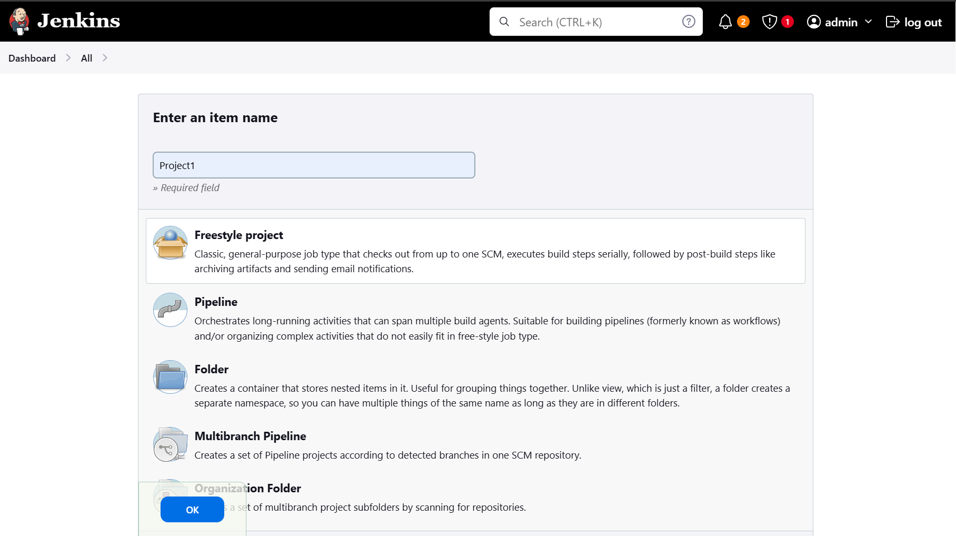

Updating Git-hu details in Jenkins

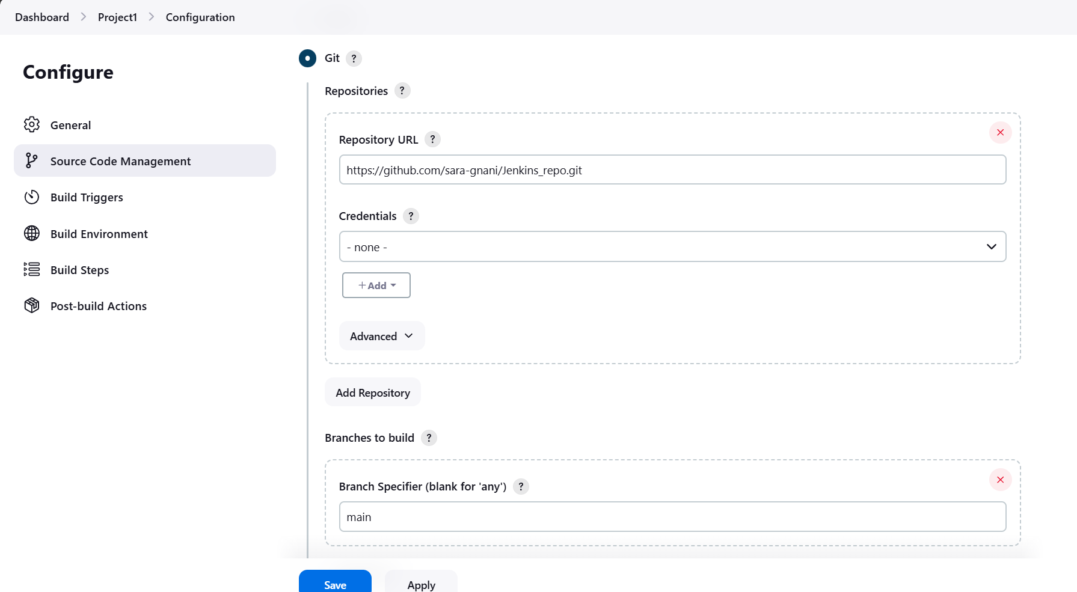

Enabling Poll SCM so that when ever any code changes happen in Git-hub, new build will happen as Jenkins will be looking the Git-hub repository every minute

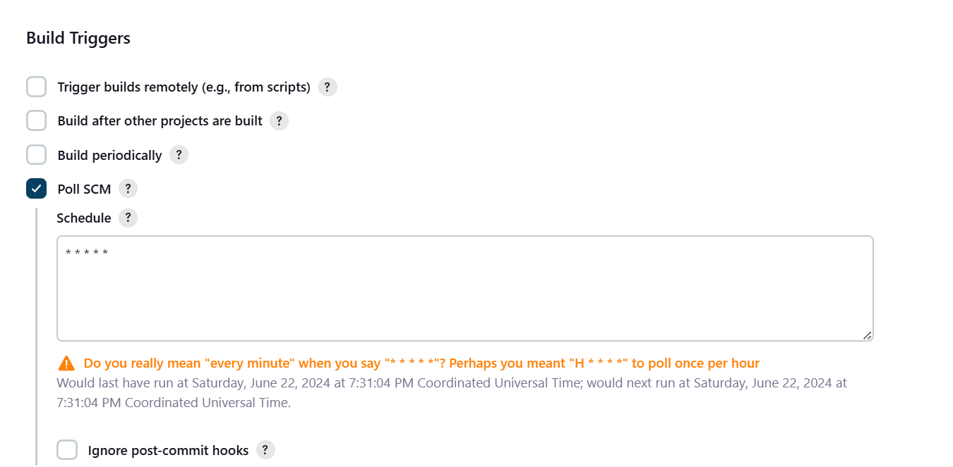

Added few Unix commands to execute the script which is present in Git-hub from Jenkins

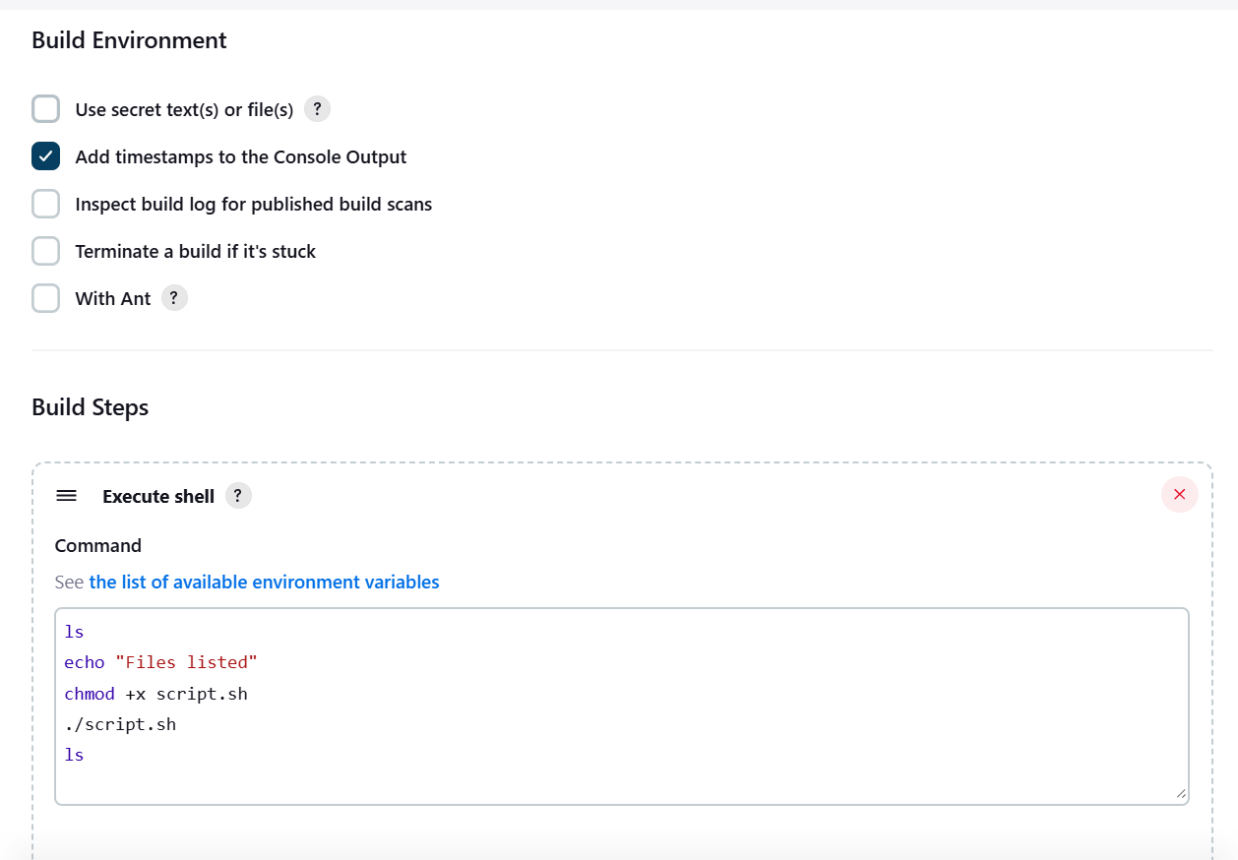

This is the Git-hub repository which is configured in Jenkins

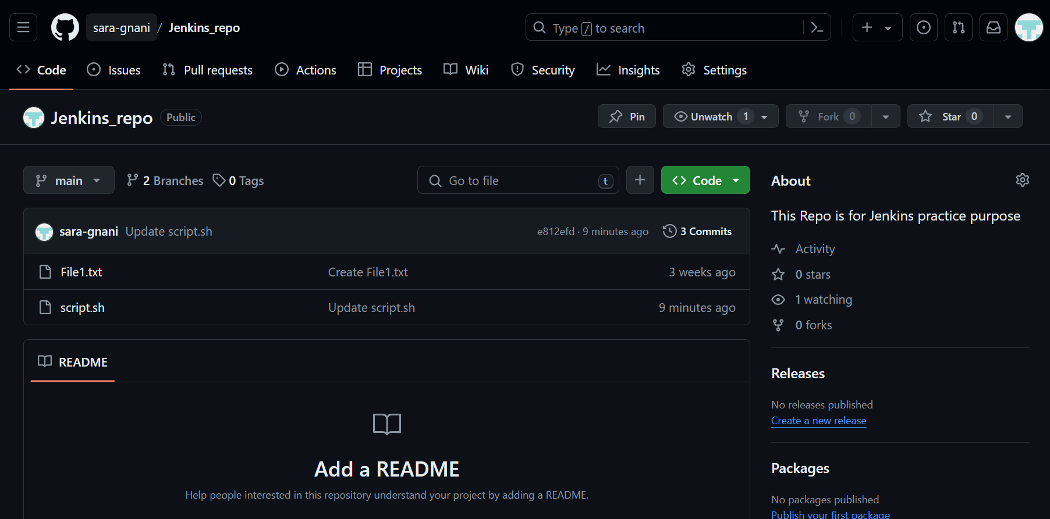

We don’t have any Builds in Jenkins

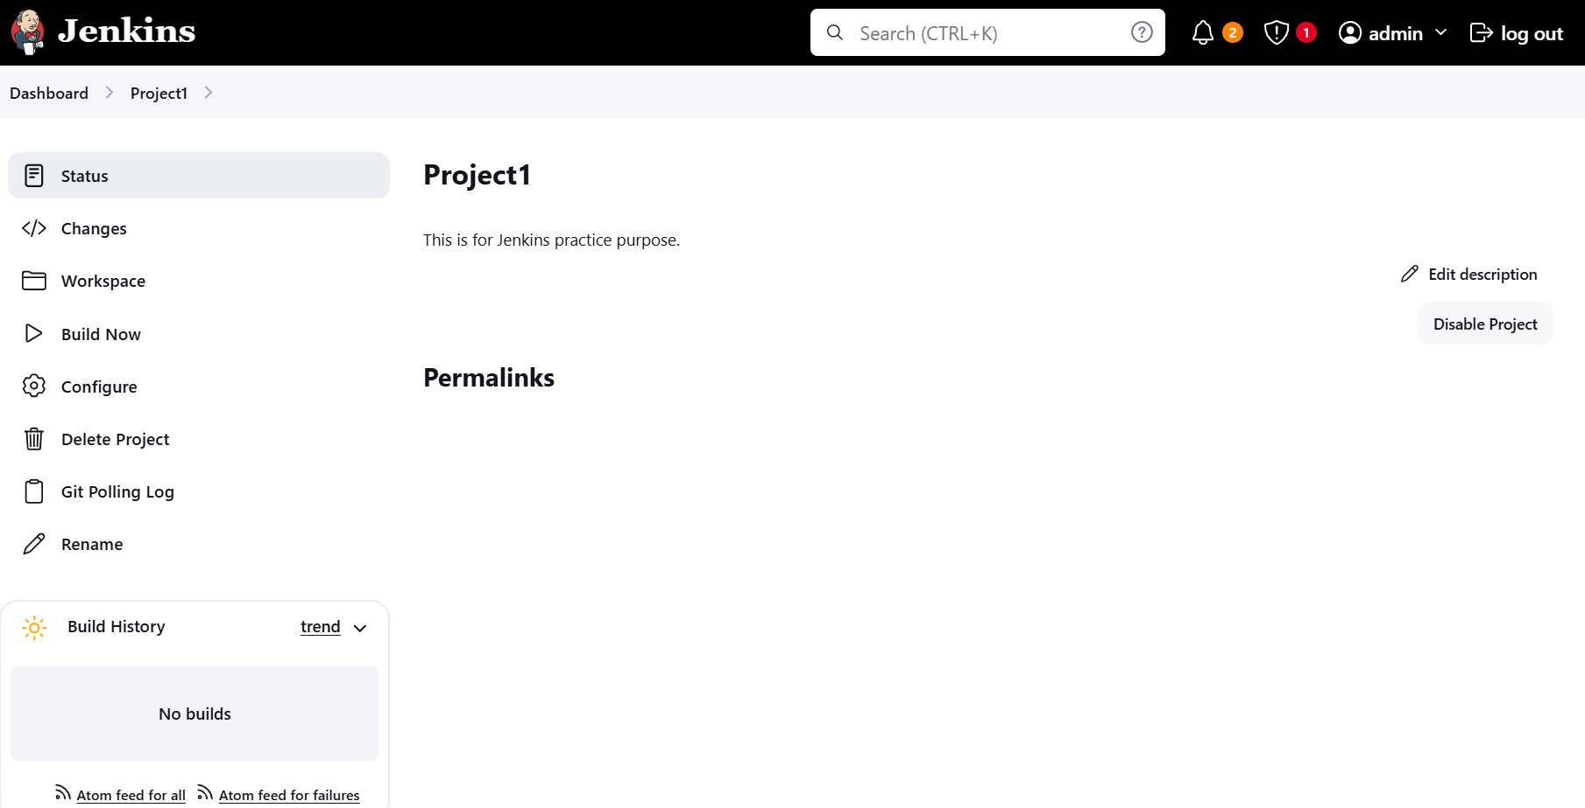

Now I’m going to make changes in script.sh script which is present in Git-hub.

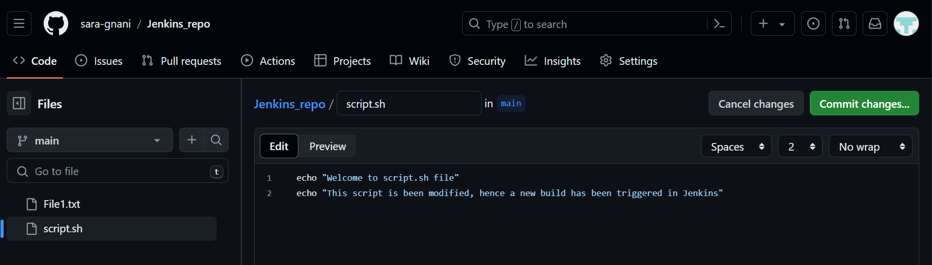

Now the New Build(#4) has been triggered and completed successfully. Build has been triggered by SCM Change

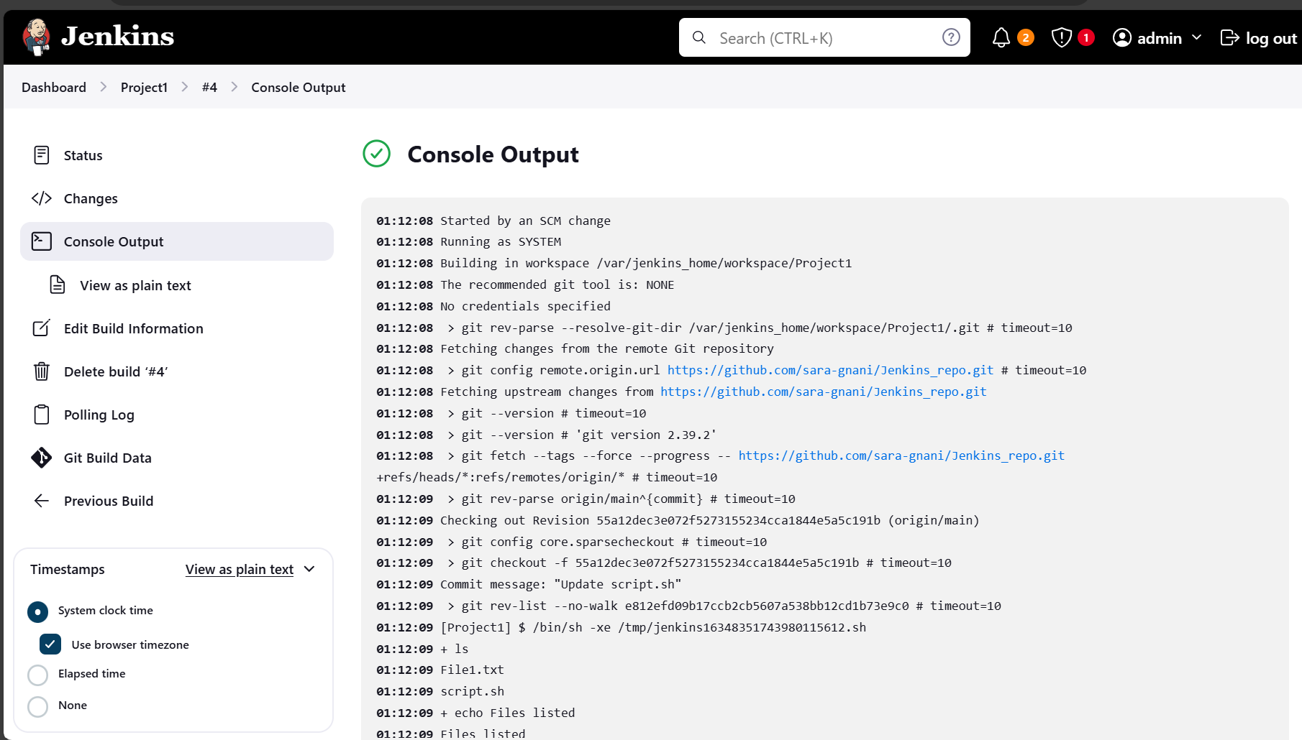



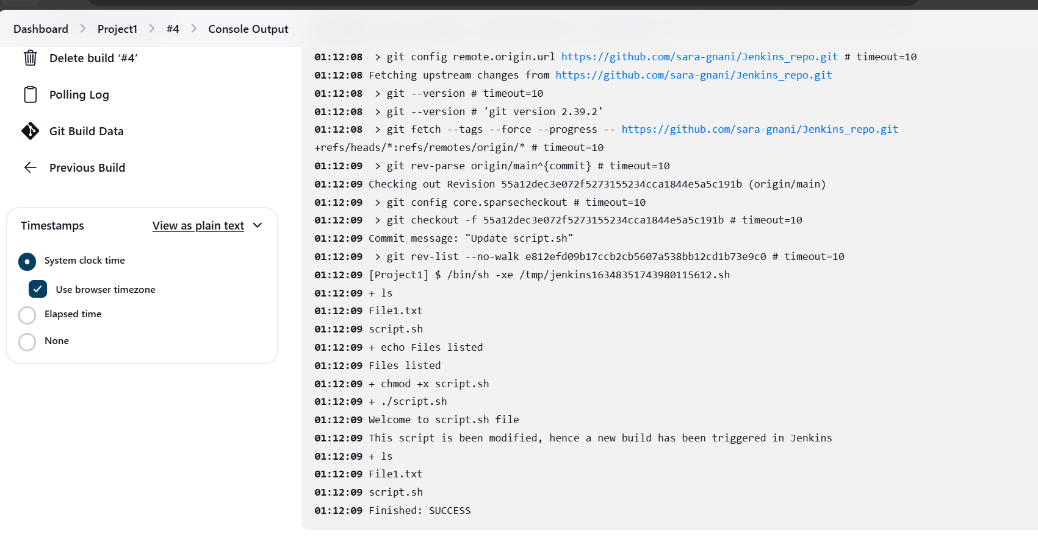

Trainer advised not to enable Email Notification has Credentials need to be added in the configurations, so I’m pasting the configuration changes that are required to enable the Email Notification without saving them below for task purpose

